Lab 01 - Manage Azure Active Directory Identities

Objectives

In this lab, we will:

* Task 1: Create and configure Azure AD users
* Task 2: Create Azure AD groups with assigned and dynamic membership
* Task 3: Create an Azure Active Directory (AD) tenant (Optional - lab environment issue)
* Task 4: Manage Azure AD guest users (Optional - lab environment issue)

## Task 1: Create and configure Azure AD users

In this task, we will create and configure Azure AD users.

New users are created in the Azure portal, in **Azure Active Directory.** In the **Users – All Users** blade we click **+ New User.** We create new user with the following settings:

| Setting | Value |
| --- | --- |
| User name | **az104-01a-aaduser1** |
| Name | **az104-01a-aaduser1** |
| Let me create the password | enabled |
| Initial password | **Provide a secure password** |
| Usage location | **United States** |
| Job title | **Cloud Administrator** |
| Department | **IT** |

To assign roles to the user we go to **Manage** section, click **Assigned roles**, then click **+ Add assignment** button and assign the **User administrator** role to **az104-01a-aaduser1**.

Using this newly created user we sign in in to the Azure portal. We use InPrivate browser to do that.

Here, we go to **Azure Active Directory.** On the Azure AD blade, we scroll down to the **Manage** section, click **User settings**, and note that we do not have permissions to modify any configuration options.

On the **Azure AD blade**, in the **Manage** section, we click **Users**, and then we click **+ New user**. This way we crate new user with the following settings:

| Setting | Value |
| --- | --- |
| User name | **az104-01a-aaduser2** |
| Name | **az104-01a-aaduser2** |
| Let me create the password | enabled |
| Initial password | **Provide a secure password** |
| Usage location | **United States** |
| Job title | **System Administrator** |
| Department | **IT** |

After we create the new user we sign out as **az104-01a-aaduser1** from the Azure portal and close the InPrivate browser window.

## Task 2: Create Azure AD groups with assigned and dynamic membership

In this task, we will create Azure Active Directory groups with assigned and dynamic membership.

Back in the Azure portal where we are signed in with our **user account**, we navigate back to the **Overview** blade of the Azure AD tenant and, in the **Manage** section, we click **Licenses**. And from there we click **All Products**. There we click **+ Try/Buy** and activate the free trial of **Azure AD Premium P2**. From the **Licenses - All products blade**, we select the **Azure Active Directory Premium P2** entry, and assign all license options of Azure AD Premium P2 to our user account and the two newly created user accounts.

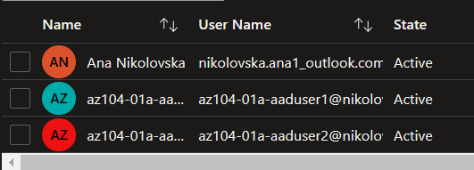

Next, we will create **Groups**. In the Azure portal, navigate back to the Azure AD tenant blade and click **Groups**. We use the **+ New group** button to create a new group with the following settings:

| Setting | Value |
| --- | --- |
| Group type | **Security** |
| Group name | **IT Cloud Administrators** |
| Group description | **Contoso IT cloud administrators** |
| Membership type | **Dynamic User** |

There we click **Add dynamic query.** On the **Configure Rules** tab of the **Dynamic membership rules** blade, create a new rule with the following settings:

| Setting | Value |
| --- | --- |
| Property | **jobTitle** |
| Operator | **Equals** |
| Value | **Cloud Administrator** |

We save the rule by clicking **+Add expression** and **Save**. Back on the **New Group** blade, click **Create**.

After this we create another Group. We do this the way created the previous group. With the following settings and the settings for the dynamic query.

New user settings:

| Setting | Value |
| --- | --- |
| Group type | **Security** |
| Group name | **IT System Administrators** |
| Group description | **Contoso IT system administrators** |
| Membership type | **Dynamic User** |

Setting dynamic query for new user:

| Setting | Value |
| --- | --- |
| Property | **jobTitle** |
| Operator | **Equals** |
| Value | **System Administrator** |

After we created the second user we create another user with the following settings:

| Setting | Value |
| --- | --- |
| Group type | **Security** |
| Group name | **IT Lab Administrators** |
| Group description | **Contoso IT Lab administrators** |
| Membership type | **Assigned** |

But here we click **No members selected.** From the **Add members** blade, we search and select the **IT Cloud Administrators** and **IT System Administrators** groups and, back on the New Group blade, click Create.

To verify that the **az104-01a-aaduser1** appears in the list of group members, we go to the **Groups - All groups** blade, click the entry representing the **IT Cloud Administrators** group and, on then display its **Members** blade.

To verify that the **az104-01a-aaduser2** appears in the list of group members, we go to the **Groups - All groups** blade, click the entry representing the **IT System Administrators** group and, on then display its **Members** blade.

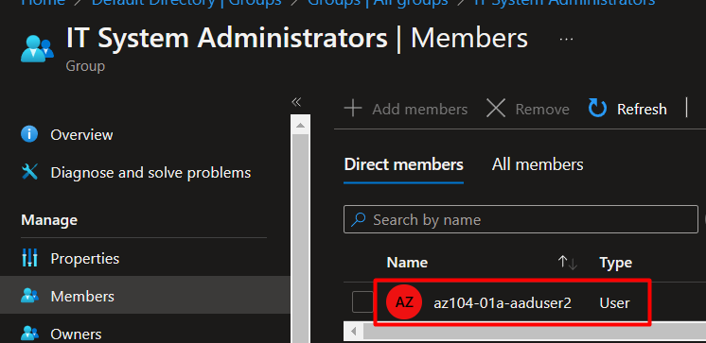

## Task 3: Create an Azure Active Directory (AD) tenant (Optional - Lab environment issue)

In this task, we will create a new Azure AD tenant.

We achieve this by going to **Azure Active Directory** and then we click **Manage tenants**, and then clicking **+Create**.

We give the following settings:

| Setting | Value |
| --- | --- |
| Directory type | **Azure Active Directory** |

Then we click **Next: Configuration** with the following settings:

| Setting | Value |
| --- | --- |
| Organization name | **Contoso Lab** |
| Initial domain name | any valid DNS name consisting of lower case letters and digits and starting with a letter |
| Country/Region | **United States** |

Note: The **Initial domain name** should not be a legitimate name that potentially matches your organization or another. The green check mark in the **Initial domain name** text box will indicate that the domain name you typed in is valid and unique.

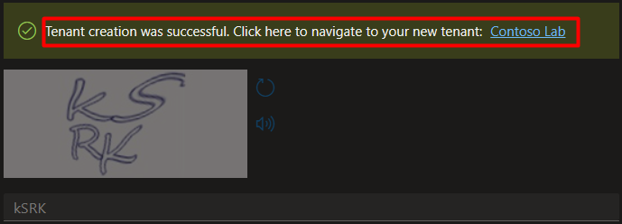

We can go to our newly created tenant by following the **Click here to navigate to your new tenant: Contoso Lab** link or the **Directory + Subscription** button (directly to the right of the Cloud Shell button) in the Azure portal toolbar.

Following the provided link:

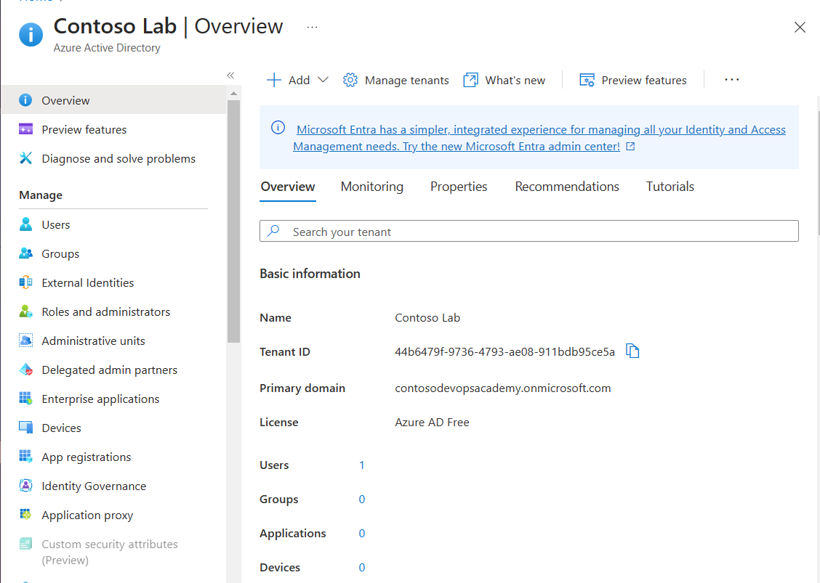

Going to the **Directory + Subscription** button in the Azure portal toolbar.

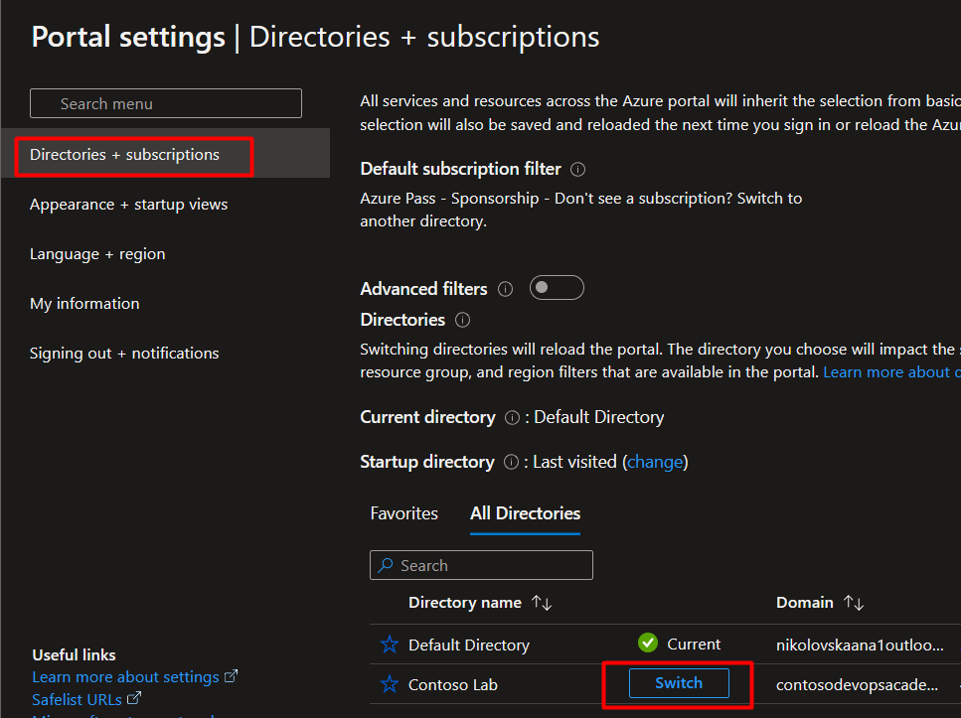

## Task 4: Manage Azure AD guest users (Optional - lab environment issue)

In this task, you will create Azure AD guest users and grant them access to resources in an Azure subscription.

In the Azure portal that is displaying the Contoso Lab Azure AD tenant, in the Manage section, we click Users, and then we click + New user. We create the new user with the following settings:

| Setting | Value |
| --- | --- |
| User name | **az104-01b-aaduser1** |
| Name | **az104-01b-aaduser1** |
| Let me create the password | enabled |
| Initial password | **Provide a secure password** |
| Job title | **System Administrator** |
| Department | **IT** |

Ana Nikolovska 
az104.01a-aaduser1 
az104.01a-aaduser2 
az104-nIb•aaduserI 
rüolovska.ana 1 
azl 04-01a-aaduserl@re 
azl 04-0 lb-aaduserl _contm 
Member 
Guest 

After this we are going back to our default Azure AD tenant by using the Directory + Subscription button. After we do that we navigate back to Users – All users blade, and then we click + Invite external user. With this we add new external user. We use the following settings:

| Setting | Value |
| --- | --- |
| Name | **az104-01b-aaduser1** |
| Email address | the User Principal Name you copied earlier in this task |
| Usage location | **United States** |
| Job title | **Lab Administrator** |
| Department | **IT** |

This guest user we add it to the IT Lab Administrators group.

az104-OIb-aaduserI I Groups 
Add memberships X Remove memberships C.) Refresh I 
Name 
IT Lab Administrators 
T C Object Id 
17c852fe-4d28-4432... 
— Columns 
Group Type 
Security 
Got feedback? 
Membership Ty„. 
Assigned 